Analysis of ABoVE Synthetic Aperture Radar (SAR) soil sensing techniques with concurrent in-situ data at field sites on the Barrow and Seward Peninsulas

**Abstract:**

As the Arctic continues to warm at increasingly rapid rates, soil properties have emerged as important considerations for our climate’s future. Lawrence et al. (2015) shows using the Community Land Model 4.5 (CLM4.5) that the soil moisture content in coming centuries will greatly factor into the global warming potential from CO2 and CH4 emissions. Therefore, accurate large scale soil moisture measurements will be crucial to understanding how our climate will respond to a warming arctic.

1. **Introduction:**

The coincident measurements were made to investigate using L- and P-band SAR data to monitor variations in aboveground woody biomass, soil moisture, and permafrost conditions (either surface deformation associated with seasonal permafrost thaw, or direct sensing of the thawed layer). A critical component of this effort includes collection of ground-based data that can be used to analyze, calibrate and validate the remote sensing products. To conduct these studies, it is highly desirable that the same field sampling protocols and the same set of data be collected at all sites so that the data from multiple sites can be combined and used to analyze variations across different landscape geomorphologies and vegetation conditions.

1. **Methods:**
   1. Data collection with Hydrosense II

The in-situ soil moisture and thaw depth measurements provided in this paper were collected coincident with airborne overflights of L- and P-band SAR instruments at the NGEE Arctic study site near Barrow, on the North Slope, and at the three study sites on the Seward Peninsula, Alaska. Field measurements and flights were conducted during the summer of 2017 as a collaboration between the NASA ABoVE Project’s Airborne SAR Campaign and the NGEE Arctic Project.

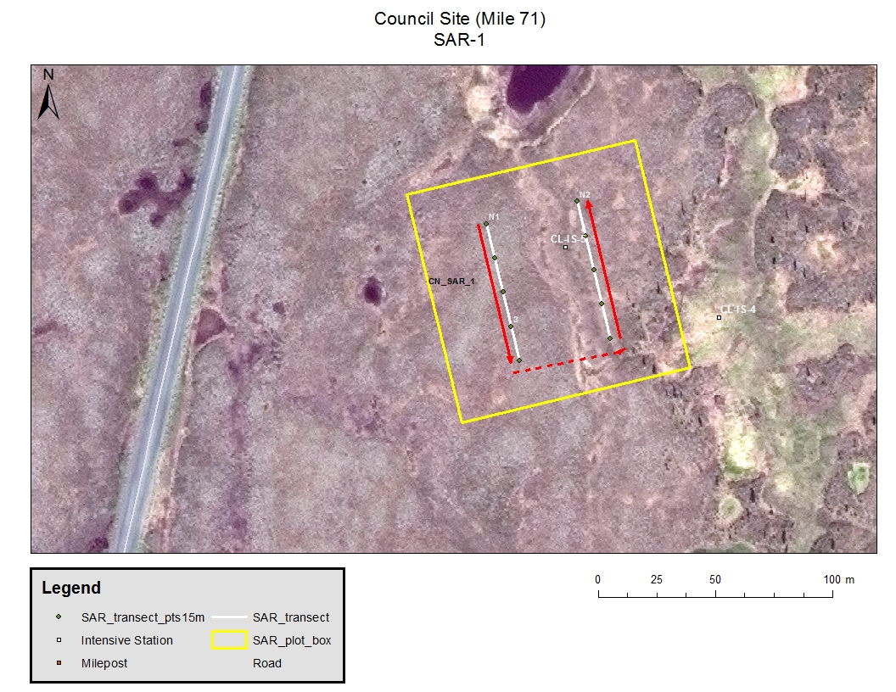

**Figure 1.** SAR Plot 1 at the Council Site on the Seward Peninsula. Plot is 100 x 100 m with two 60-m transects and showing flag locations for soil moisture measurements along each transect. The red lines indicate where thaw depth was measured.

ABoVE protocols for establishing field measurement plots were followed. The optimum plot size for SAR studies is one hectare or 100 x 100 m. This size will produce enough ground area for averaging of multiple pixels for both airborne and spaceborne SAR data. The first step in setting up a field plot was to identify a one-hectare area that has a relatively homogeneous vegetation cover. Because ground conditions in Arctic ecosystems are highly variable at meter to sub-meter scales, it is necessary to employ a sampling scheme that captures this smaller scale variability. Two 60-m long sample transects were established, as outlined in Figure 1, to systematically sample the site for soil moisture, thaw depth, and organic layer thickness in each plot.

NGEE Arctic plots for the ground-based measurements are located at existing study sites where SAR data would also add value to current monitoring and characterization efforts of the NGEE Team. Plot locations were chosen by their proximity to intensive sites, spatial separation, and vegetation type diversity.

* At Barrow, 3 plots were established and sampled in June and September, 2017. See Appendix Figure 1.
* On the Seward Peninsula, 2 plots were established and sampled at Council, 4 at Teller, and 3 at Kougarok during May and August, 2017. See Appendix Figures 2, 3, and 4.
* Twelve “SAR plots” total.

Soil Moisture

A Hydrosense II probe and data logger (with GPS) were used to measure soil moisture properties.

Along each 60-meter transect, 3 sampling spots were flagged every 15 meters for soil moisture parameter collection. Fifteen measurements were collected in a semi-circle at each sampling spot (90 per plot), that is five at 6 cm (60 degree angle), five at 12 cm, and five at 20 cm depths.

Thaw Depth

Using the two 60 m transects, thaw depth measurements were collected using a frost probe every 5 m along each transect, beginning at 0 m, which resulted in 13 samples per transect and 26 per plot. Surface conditions and any obstacles encountered while probing that would influence the measurement were noted.

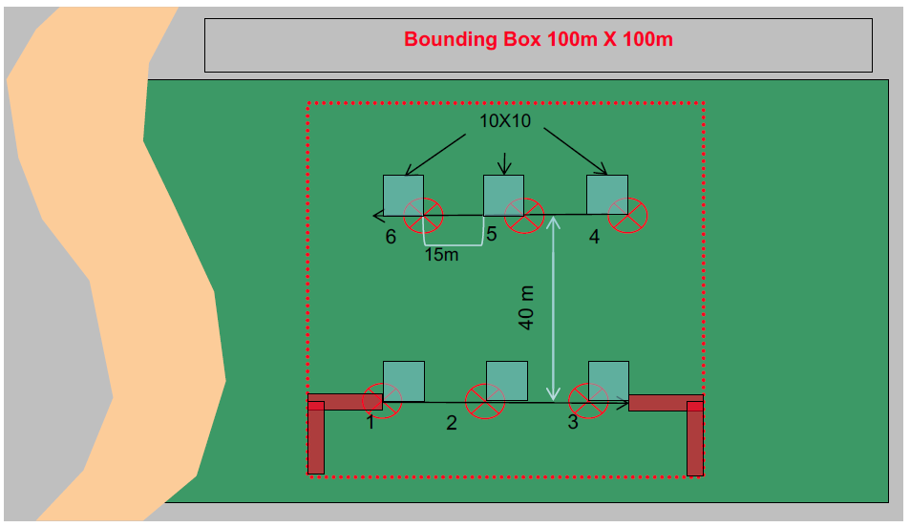

**Figure 2.** Plot sampling scheme. For soil moisture, three sampling points were established along each 60-m transect (red circles). Thaw depth was measured every 5 m (starting at 0) along both transects.

**Volumetric Water Content**

Volumetric water content data were collected using a Hydrosense II soil-water sensor and data logger which collected the GPS location of the moisture samples. Hydrosense sensor rely on soil dielectric properties to estimate volumetric water content (VWC). Each SAR plot consisted of two 60 meter transects with 3 flags for soil field parameter collection.

The moisture measurements were taken at flags located at 15, 30, and 45 meters along each transects. At each flag 15 measurement were collected from 5 approximately collocated locations as showing in Figure 2: five at 6 cm, five at 12 cm and five at 20 cm.

The 6 cm samples were collected by inserting the vertical 12cm probe at a 60-degree angle to the horizon and for the 12 and 20 cm samples, the 12 and 20 cm probes, respectively, were inserted vertically, Figure 4. A total of 90 moisture measurements were taken at each SAR plot as long as there were no rocks, snow or the ground was frozen.

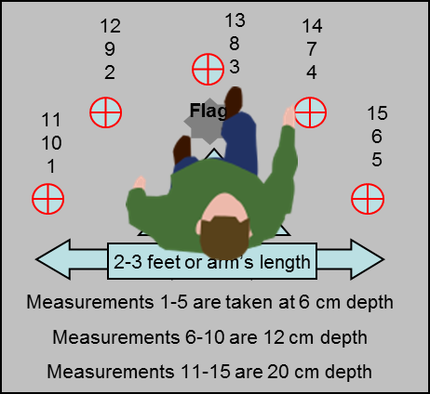

**Figure 3.** Example of how the moisture measurements were taken at each flag.

**Figure 4.** A diagram of how the Hydrosense II probes were inserted to collect data at varying depths.

**1.2 cm FFMC**

**7.0 cm DMC**

6 cm

60 degree insertion from vertical of 12 cm probe

12 & 20 cm

vertical insertion

60 degrees

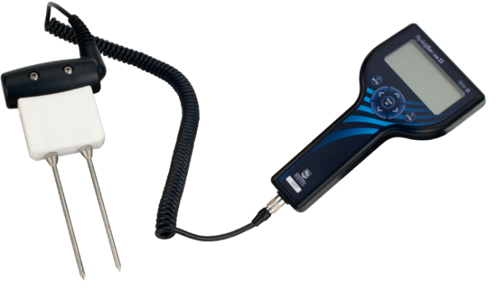

* 1. ABoVE SAR data collection
  2. Chen et al. 2018 procedure to get VWC/dielectric constant profiles
  3. Calibration procedure of the in-situ data

# Hydrosense Soil-Water Sensor Calibrations

Calibrations to Hydrosense II data taken between June and September at Barrow and Seward sites are based on the general algorithm specified by the ABoVE Project’s, Laura Bourgeau-Chavez ([lchavez@mtu.edu](mailto:lchavez@mtu.edu)).

After going through soil classifications as specified and performing the calculations, we were still getting numbers that did not make sense. After discussion, Laura came to the conclusion that our soil must have been significantly different from their lab soil and that we should use the coefficients specified below. Laura and her lab techs did not measure 6 cm with the Hydrosense II (our instrument), she advised us to use the 12-cm coefficients for the 6-cm measurements.

|  |  |  |  |  |  |  |  |
| --- | --- | --- | --- | --- | --- | --- | --- |
| **Group** | **Probe** | **Probe Depth** | **A** | **B** | **C** | **R2** | **Standard Error** |
| General | HydroSense II | 20 cm | 7.693 | 1.641 | -12.341 | 0.8873 | 5.773 |
| General | HydroSense II | 12 cm | -24.28 | 134.55 | -110.245 | 0.8294 | 7.102 |
| General | HydroSense II | 10 cm | -5.307 | 58.327 | -64.615 | 0.7621 | 8.388 |

**Calculation of VWC using Hydrosense II Calibration Coefficients**

Where θ is the volumetric water content (% VWC), τ is the period in microseconds, and A, B, C are coefficients from the table above that are based on lab measurements of soils.

For more information refer to the NASA_ABOVE_CalibrationSummary_20171115.pdf companion file and:

Bourgeau-Chavez, L., Garwood, G. C., Riordan, K., Koziol, B. W., & Slawski, J. (2010). Calibration algorithm development for selected water content reflectometers to organic soils of Alaska. International Journal of Wildland Fire, 19(7), 961-975. <http://dx.doi.org/10.1071/WF07175>

The provided VWC data were derived with these coefficients.

1. **Analysis:**
2. **Conclusions:**